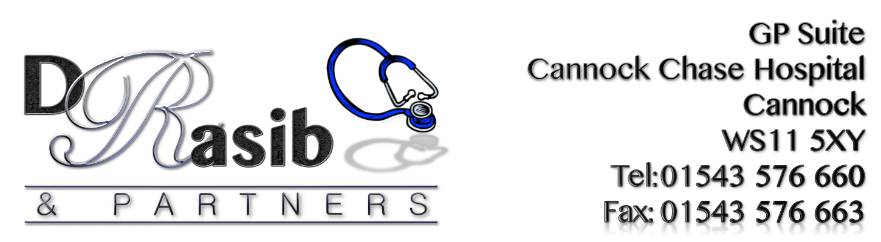
RESULTS FOR PRACTICE IMPROVEMENT SURVEY OCTOBER 2019

86% of patients stated that the speed at which the telephone was answered initially was either excellent, very good or good. This has improved since last year’s results. Still some improvement needed with answering the phone. This item is to be included on the Action Plan.

78% of patients stated that the length of time that they had to wait for an appointment was either excellent, very good, good. - This has improved since last year’s results - No action required but will continue to monitor this

91% of patients stated that seeing the Doctor of their choice was either Excellent, Very good or good. No action required but will continue to monitor.

85% of patients stated excellent, very good or good when asked what they thought about the opportunity of being able to speak to a doctor or nurse when necessary – No action required

95% of patients stated excellent, very good or good when asked what they thought about their overall experience of the practice– No action required

100% % of patients stated they would like to being able to appointments in advance rather then using the current system which means most appointments are offered as same day appointments. This item is to be included on the Action Plan.

91% of patients surveyed stated that they felt that the introduction of a text messaging service would be helpful. This item is to be included on the Action Plan

